Judge numbers v0.9e — numbers only (SHORT headline; base case PT = $0)
All $/MW = revenue per billed IT MW-yr. Spot $237.15 (Oct 7 close) [R]. Tags: R Reported / D Derived / E Estimated. Every PT below is a run_full solve (none is an interpolation).
1) PRICE: non-MSFT hurdle ~$27.6M per billed MW [D] (Street FY27 $12.3B minus Microsoft FY27 $2,644M, over 349.5 non-Vineland billed MW) vs the disclosed band $9.7–16.7M (top = Lambda–Anthropic) [D]. Blended Street ~$23.1M [D]. To justify $237.15 the market needs $24.51M GB300 / $24.82M Rubin (base, 11% WACC) [D].
2) MW: at $16M comps the Street needs 768.75 MW ($12.3B / $16M) [D] = 1.45x our 531.8 base (~237 short) and 1.17x our 659.2 high (~110 short) [D].
3) CLEAR-SPOT: $24.51M base / $22.68M high (Judge basis; Rubin $24.82M / $22.96M) [D].
4) PT AT PRICE (Judge basis): ≈$0 at every disclosed price in the band (base $0; high $0.05 at the $16.7M top) [D]; Lambda's actual print $16.67M [D, press inputs, medium confidence] = $0 on both paths (high zero at $16.6976M) [D]; $0–15 at $17M (the $15.43 high = hypothetical if Lambda's run-rate rises) [D]; $39–63 at $18M [D]; at the Bitdeer $22.4M ceiling, high ~$228 next to base ~$178 — the $228 is the best case (high path, every uncontracted MW repriced); the base case is $0 [D]. Deck line: "At every disclosed contract price ($9.7M to $16.7M), the PT is ~$0. At ~$17M it's $0–15, and even $18M only gets $39–63, against $237."
Grid excerpt (Judge basis; 12m PT $/share) — marked rows
GB300 $M | Rubin $M | Marker | PT base $ | PT high $
16.7 | 16.91 | band top (Lambda–Anthropic) | 0.00 | 0.05
16.67 | 16.88 | Lambda actual print (press inputs, med. conf.); below $16.6976 zero | 0.00 | 0.00
16.70 | 16.91 | turn-positive HIGH (Judge): first PT > 0; $0 at $16.6976 | 0.00 | 0.09
17.0 | 17.21 | ~$17M (high $15.43 = hypothetical if Lambda run-rate rises) | 0.00 | 15.43
17.05 | 17.26 | turn-positive BASE (Judge): first PT > 0; $0 at $17.0432 | 0.12 | 17.77
18.0 | 18.23 | $18M | 39.02 | 62.74
22.4 | 22.68 | Bitdeer A201 ceiling, MW basis unstated | 177.68 (base) | 227.72 best case: high path, every uncontracted MW repriced
22.68 | 22.96 | high-path clear-spot | 187.90 | 237.12
24.51 | 24.82 | base clear-spot (Judge line 1) | 237.10 | 298.45
27.6 | 27.95 | non-MSFT hurdle | 322.21 | 401.18
Turn-positive points (Judge basis): high $16.70M (PT $0.09; $0 at $16.6976M) / base $17.05M (PT $0.12; $0 at $17.0432M) [D]; Lambda's $16.67M print is $0 on both paths [D].
Kill lines: HIGH path tracking (9/30 billed MW + Q4 plan consistent with YE26 ≥284.2) AND new deals ≥$22.7M/MW on ≥100 MW or ≥$2B TCV [E]; else new deals ≥$24.51M/MW (base clear-spot) [D]; ≥5 of 9 MSFT tranches billing [D]. A single 15–20 MW print does not break the short.
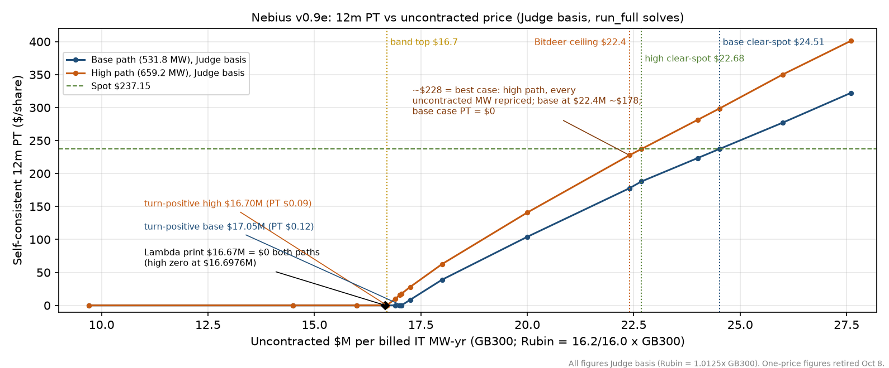
Sources/tags: spot $237.15 [R, Oct 7 close]; band $9.7–16.7M [D, comps; top = Lambda–Anthropic ~$35B / 6 yrs / ~350 MW]; Bitdeer A201 ceiling ≤$22.4M [D, MW basis unstated]; all PTs and clear-spot prices [D, nebius_model.xlsx v0.9e Debate_Grid, harness run_full 2026-10-08 15:14–15:21 ET: 3-tier new-note switch $313.46/$324.65, older notes per tranche at the PT, accreted at the PT date, MatCvPx second pass]; kill size bar ≥100 MW / ≥$2B TCV [E, uncontracted MW not disclosed]. Base case PT = $0.
All figures Judge basis (Rubin = 1.0125× GB300). One-price figures retired Oct 8.

